Learning With Errors Visualization Lab
Applied Mathematics / Computer Science
Name:
Date:
Objective
In this activity, you will use SageMath to explore the Learninng With Errors (LWE) problem. You will observe how adding small random error changes modular linear equations and why this makes recovering a secret significantly more difficult.
Learning Objectives
By the end of this activity, you should be able to:
- Explain the components of the LWE equation.
- Describe how random error affects the public outputs.
- Interpret graphical representations of noisy data.
- Explain why recovery the secret becomes computationally difficult.
Background
The simplified LWE equation is
$$b=A∙s+e \left(mod q\right)$$
Where,
- A = Public matrix
- s = Secret vector
- e = Random error vector
- q = Modulus
- b = Public output
Without error:
$$b=A∙s \left(mod q\right)$$
The system behaves more like ordinary linear algebra. When small random error is added, the secret becomes harder to recover.
Attack Methods Comparison
Attack | Main Idea | Works If A is Not Square | Used in Real LWE
Linear Algebra | Compute $A^{-1}b$ | No | No
Brute Force | Guess every possible secret | Yes | Only for toy examples
Lattice Reduction LLL/BKZ | Search for lattice vectors | Yes | Yes
BKW | Combine equations to eliminate variables | Yes | Yes
Hybrid | Combine brute force with lattice reduction | Yes | Yes

Part 1: Default Run
Run the SageMath program using the default values.
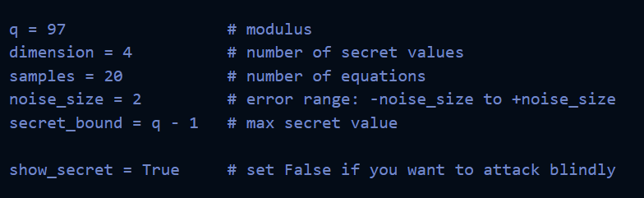
Record the Output
Quantity | Values
Public Matrix (A), first row
Error Values
Clean Outputs
Noisey Outputs
Attack Successful?
Guesses Checked
Attack Time

Question 1
What effect does the random error have on the public outputs?
Answer:

Question 2
Why does the Linear Algebra attack Fail in this demonstration?
☐ Because the modulus is too large.
☐ Because the matrix $A$is not square.
☐ Because the secret is too small.
☐ Because brute force is faster.

Question 3
Which attack recovered the secret the fastest?
Answer:

Part 2: Scatter Plot Analysis
Open:
lwe_scatter_plot.png
Insert Plot

Question 2
Describe the relationship between the blue and red.
Answer:
Open:
lwe_clean_va_noisy.png

Question 5
What does the dashed blue line represent?
Answer:

Question 6
Why do most of the red points remain close to the dashed blue line?
Answer:

Part 4: Noise Experiment
Change only the noise value and run the program three times.
Noise Size | What happened to the red points? | Was the attack easier or harder?
0
2
8

Question 7
Which noise value appeared to provide the least security?
Answer:

Question 8
Why doesn’t simply increasing the noise forever produce a better cryptosystem?
Answer:

Final Reflection
In 3-5 sentences, explain why LWE is considered a strong mathematical foundation for post-quantum cryptography. Include one thing you learned from the SageMath demonstrations.
Answer:

